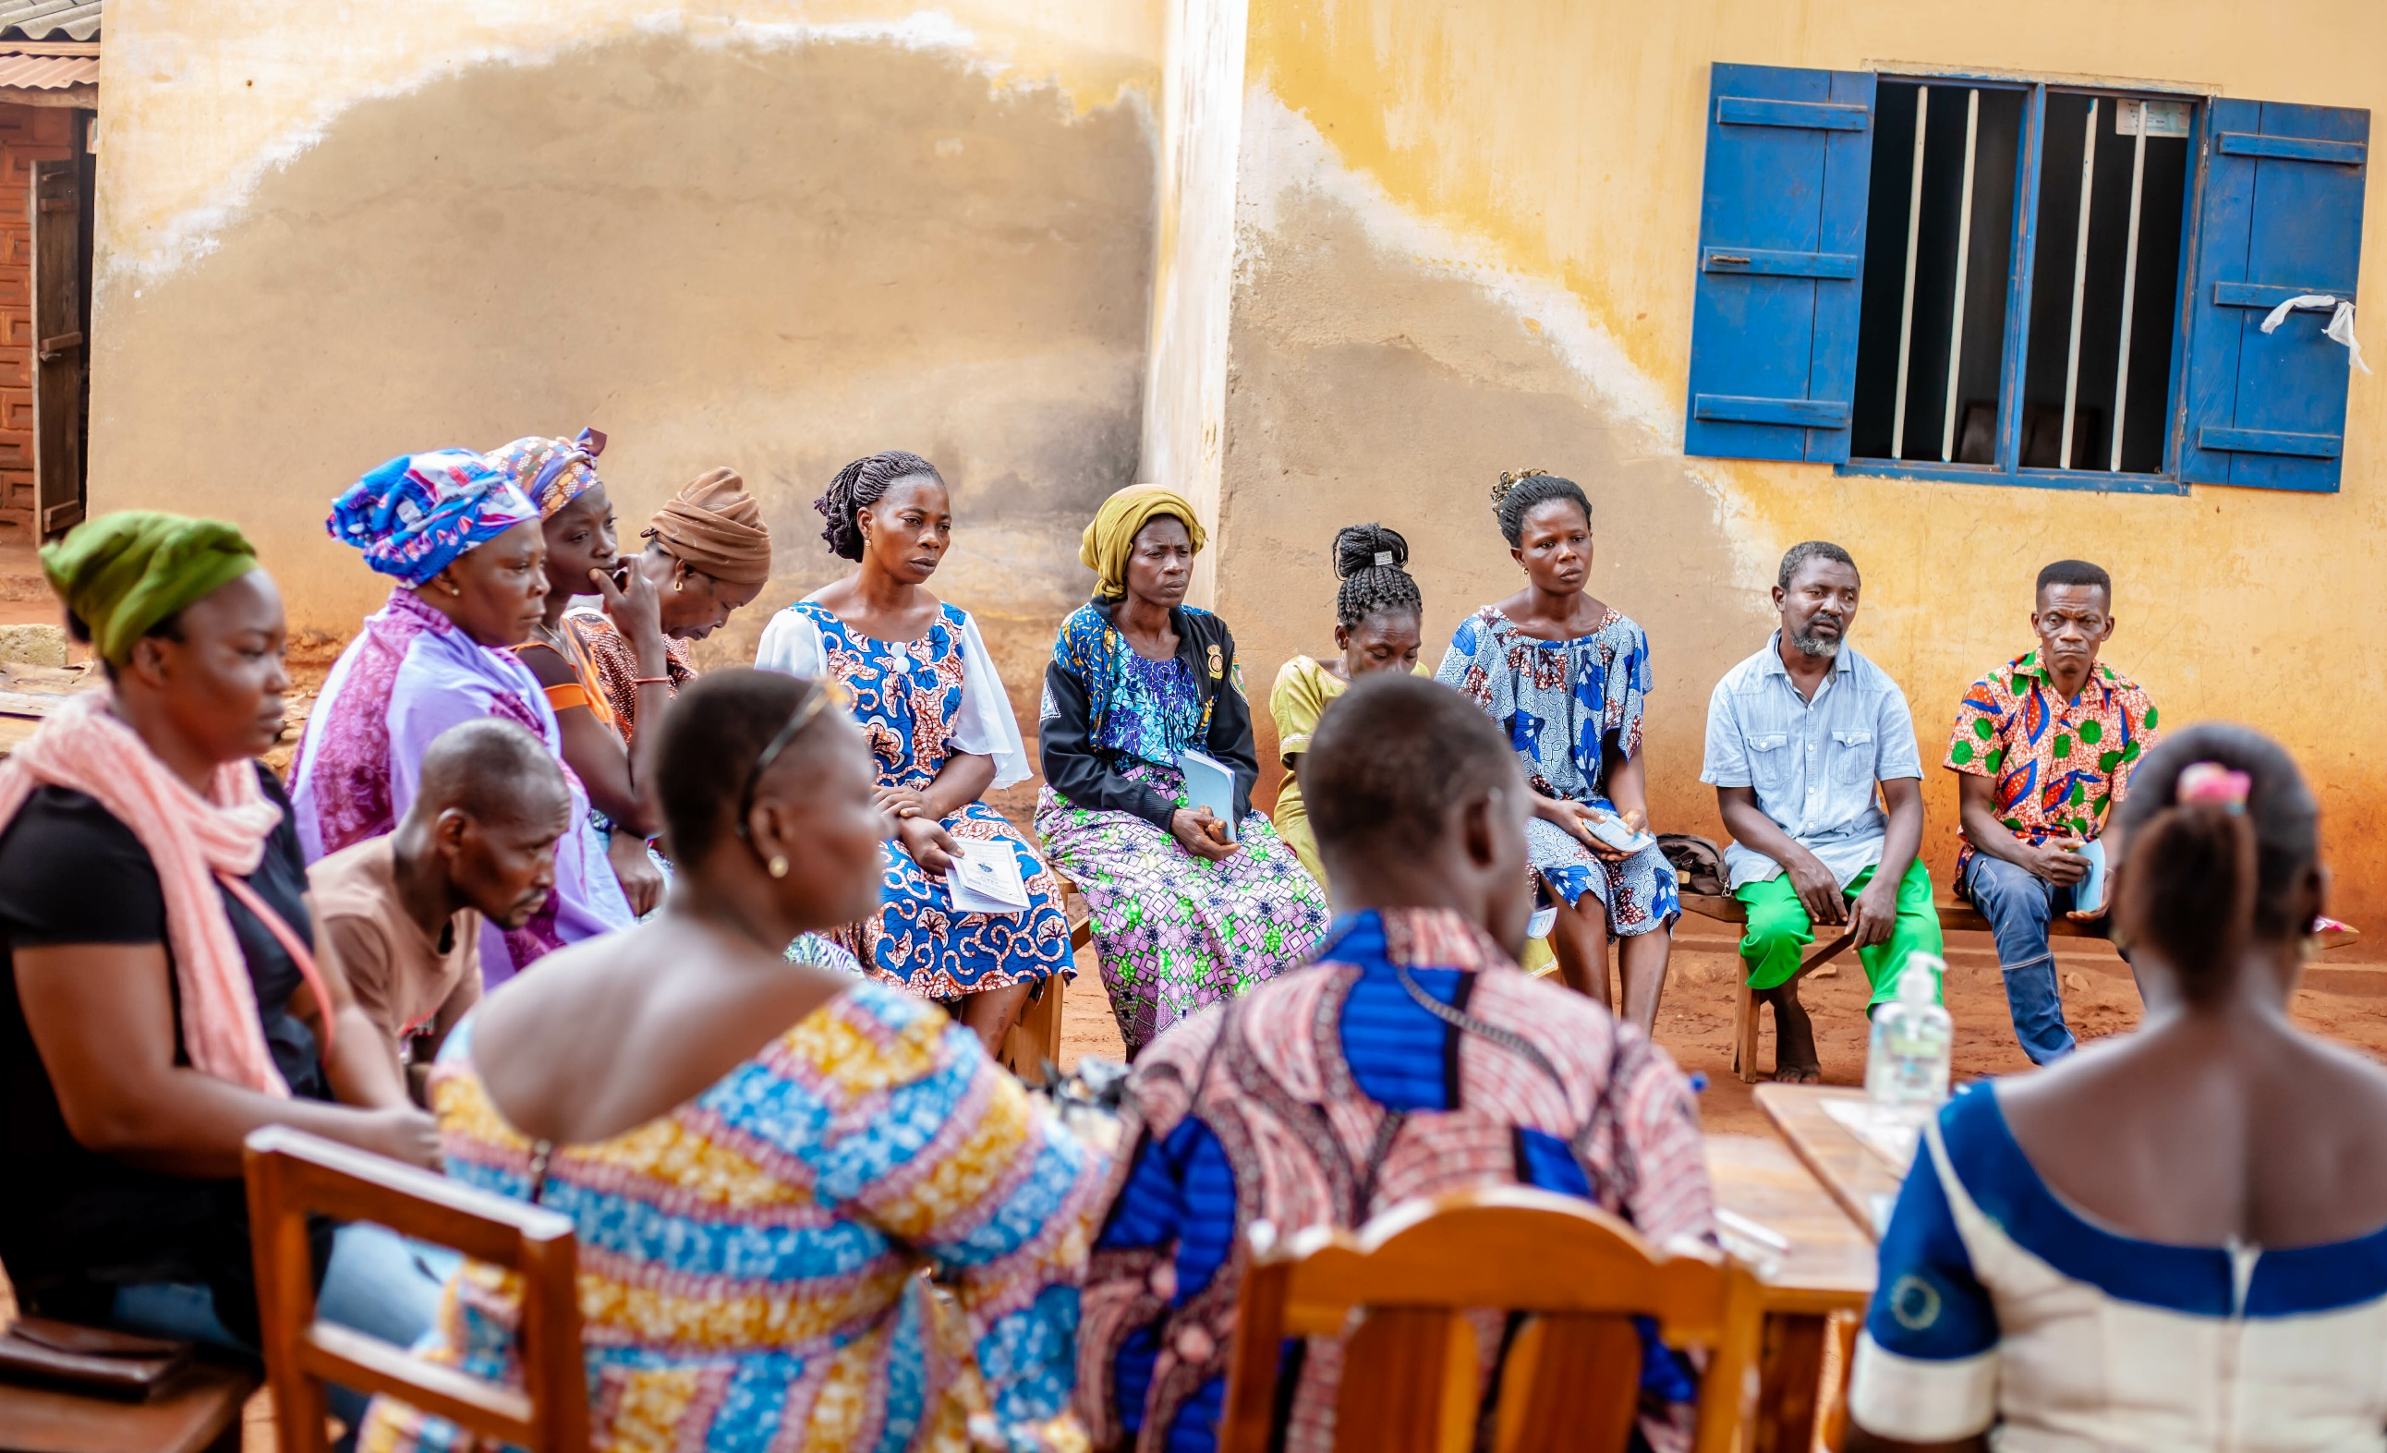

The Lost Link
Localization of the UN Convention on
the Rights of Persons with Disabilities

Jörg Weber, Shaun Grech, Sarah Rule with Floyd Morris, Paul E. Muego, Netricia Miller, Richard Vergunst, Retselesitsoe Monne

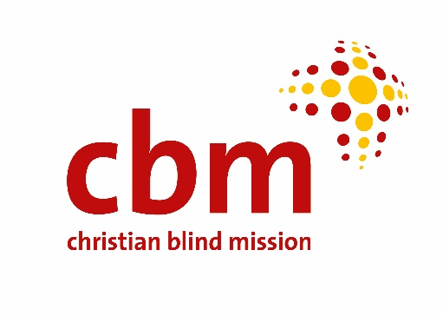

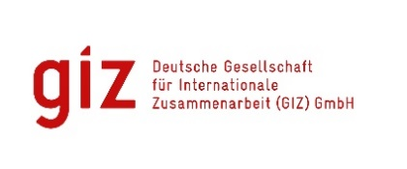
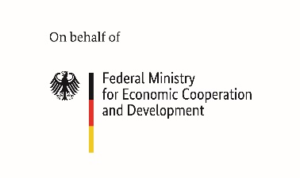

Gratitude
We would like to express our gratitude to all participants from the 5 countries who generously gave their time and offered their wealth of knowledge and experience.
Parts of the project were conducted thanks to Deutsche Gesellschaft für Internationale Zusammenarbeit (GIZ) GmbH with funding from the German Federal Ministry for Economic Cooperation and Development.

© CBM 2022. This report may be copied, downloaded and shared for educational, organisational and policy purposes. We simply ask that none of the content is changed and that the original source is acknowledged.
SUGGESTED CITATION:Weber, J., Grech, S., Rule, S., Morris, F., Muego, P.E., Miller, N., Vergunst, R. and Monne, R. (2022). The Lost Link: Localization of the UN Convention on the Rights of Persons with Disabilities. Germany: CBM
Title page photo: Meeting of the saving group VSLA Novilonlon in Togo. Photo: CBM

Executive Summary
The UN Convention on the Rights of Persons with Disabilities (CRPD) remains in place as the major disability rights instrument with a targeted focus on social development, grounded in the recognition that all persons with disabilities, with no exception, must enjoy all human rights and fundamental freedoms as every other person. However, the CRPD does not automatically confer realization of these rights for persons with disabilities, especially those at a local level, and indeed its ratification is but a start. Like any other international human rights convention, the CRPD needs to be entrenched in domestic policies and systems by national governments and other authorities to ensure a harmonized application that is then actively monitored. It means cultural and ideological change and socio-economic development. Even more importantly, its success hinges on its implementation and enforcement at the most local level, which is where marginalisation and deprivation may be most pronounced, especially in poor areas in the global South.
In response to this, recent years have seen increasing focus on what is fluidly termed ‘localization’ to highlight a process whereby international frameworks respond to and make a concrete difference in the daily lives of people in their homes and communities. Localization has also started to appear in international human rights law, demarcating a process of support for national, regional, and local governments, civil society and others in developing mechanisms and practices that effectively translate the CRPD into concrete practice and benefits on the ground. However, in practice, the implementation of the CRPD is far from simple, and the process of localization is frequently met by multiple and complex hurdles, most pronounced at the local level, where social, historical and other factors come into play. This meets a dearth of research exploring and documenting the process of implementation ‘on the ground’ in a range of contexts, meaning not only conceptual, but also policy and practice limitations. Overall, what we are left with is a scenario of deep fragmentation when it comes to the localization of the CRPD, meeting assumptions about the CRPD and its potential, too often left unquestioned.
This report presents the findings from a research project incorporating 3 studies to look at the extent to which the CRPD is being localized, and the factors and processes impacting the process of localization with a view to understanding the gaps and opportunity areas. The findings highlight a scenario of fragmentation and multiple barriers, becoming more pronounced in local rural areas in the global South. They demonstrate how “localization” still faces conceptual gaps, which means that we often do not know what we are actually talking about, and consequently how to set out to do it. This meets other barriers including: a focus on individual rights (as opposed to more communal ones); challenges faced by OPDs, their functionings and capacities; political and legal issues; representation concerns; a siloed approach where disability inclusion is marginalised in mainstream areas; lack of awareness of the CRPD; fragmented data; and socio-economic and cultural dimensions among others. Overall, while localization does happen on its own accord, the process is neither strategic nor harmonized, but is instead unsystematic and erratic, each local context left to its own devices. These barriers are accentuated as intersectional dimensions are factored in, including indigeneity, age, gender, race and ethnicity.
The study concludes with a number of general and specific recommendations, including: the need for active work on the conceptualization of ‘localization’ of the CRPD that establishes this as a systemic approach in its own right; a requirement to move towards the understanding and implementation of the localization of the CRPD as an ongoing process; responsiveness to context; the CRPD committee issuing a general comment on localization, to ensure that reporting procedures to the CRPD committee genuinely reflect local concerns; sensitization of UN country offices on the CRPD; generation of quality local data on disability; and support for countries to identify priority areas for localization and to develop a comprehensive strategic plan for localization. The recommendations go on to stress the need to ensure there are more individuals at a political directorate level who understand the CRPD and can effectively influence its implementation. Furthermore, they point to the need for a local budget and funding to be made available; to review national policy frameworks and laws; and to work with local OPDs as genuine participants in the governance process. It is critically important to ensure that OPDs are genuinely representative of all persons with disabilities, especially those in marginalised rural areas and not only a select privileged few.

