30.03.2020

CBM Develops ‘Disability Inclusive Community Action –COVID-19 Matrix’
“Disability Inclusive Community Action – COVID-19 Matrix” has been developed with the aim to provide community programmes guidance on possible action points in community development and mobilization in relation to COVID-19 preparedness and response.
The matrix is not intended to be a comprehensive implementation tool. It rather aims at providing brief and clear action points, that can easily be adapted to the local context and give CBID programme managers ‘keywords’ and anchors for engaging with local governments and service providers and holding them accountable.
The action points as listed in the matrix emphasize the importance of pro-active community development responses and encourage community stakeholders to work collaboratively to respond to the COVID-19 challenge.

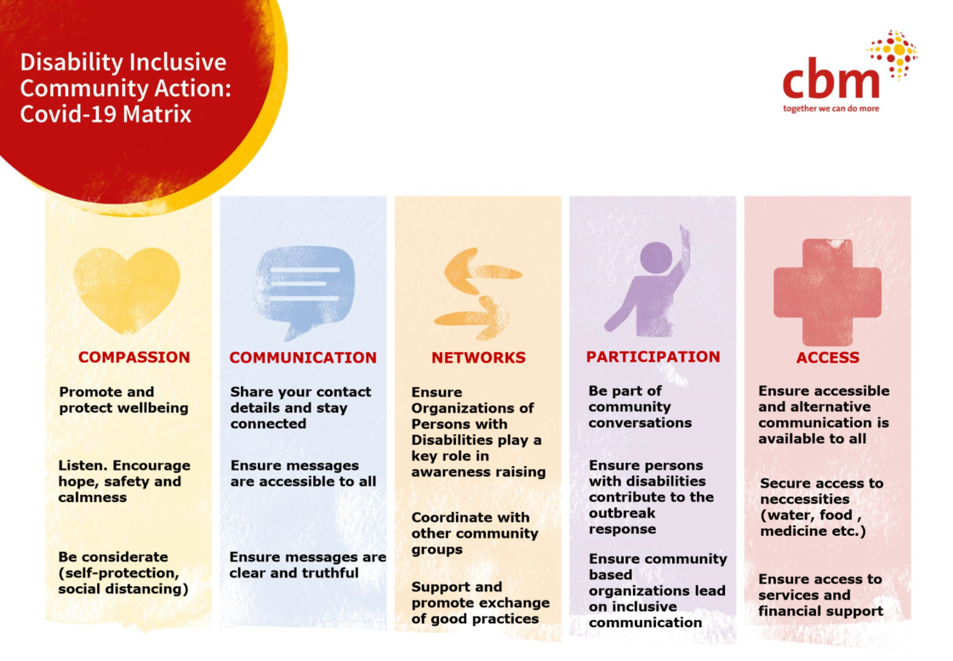The COVID-19 Matrix by CBM in English (Photo © CBM)
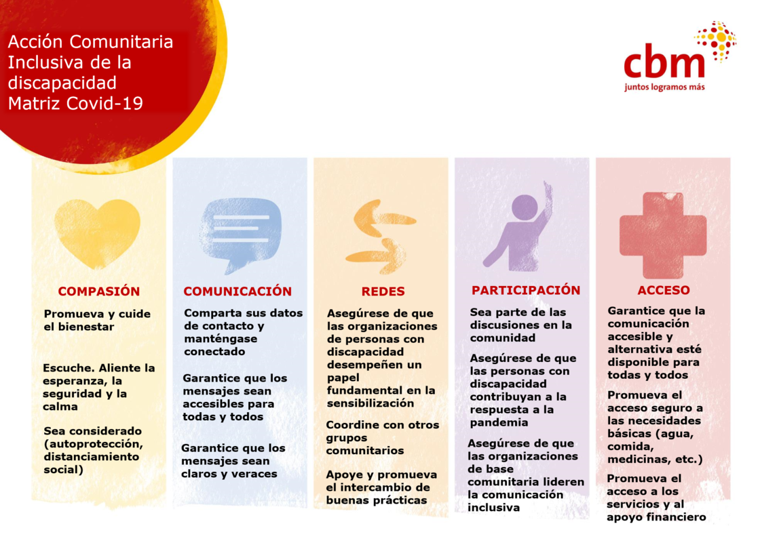The COVID-19 Matrix in Spanish (Photo © CBM)
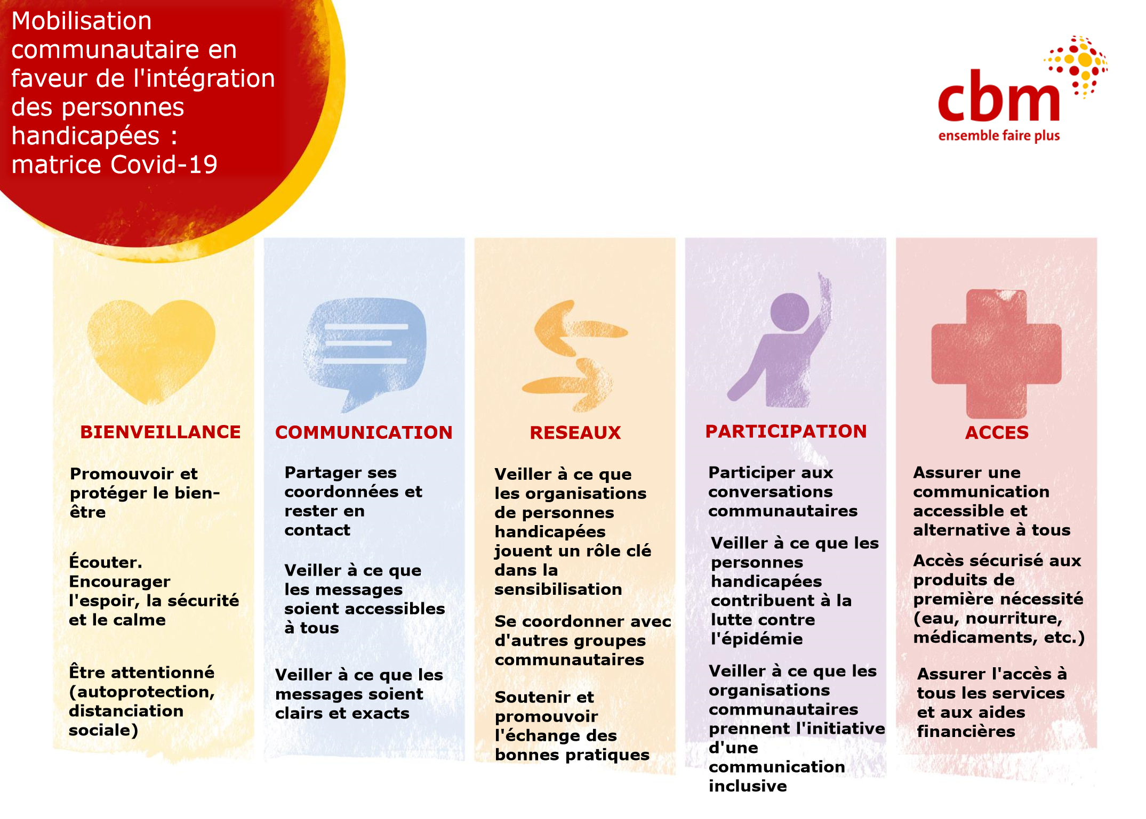The COVID-19 Matrix in French (Photo © CBM)

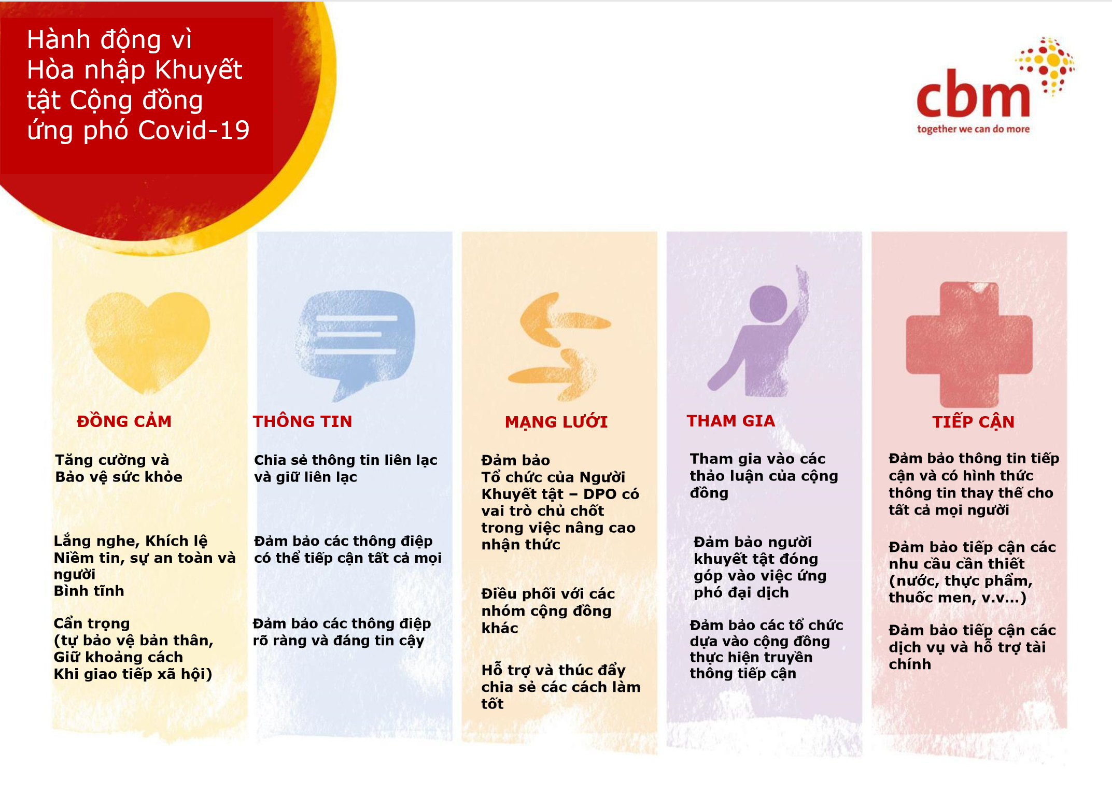The COVID-19 Matrix in Vietnamese (Photo © CBM)
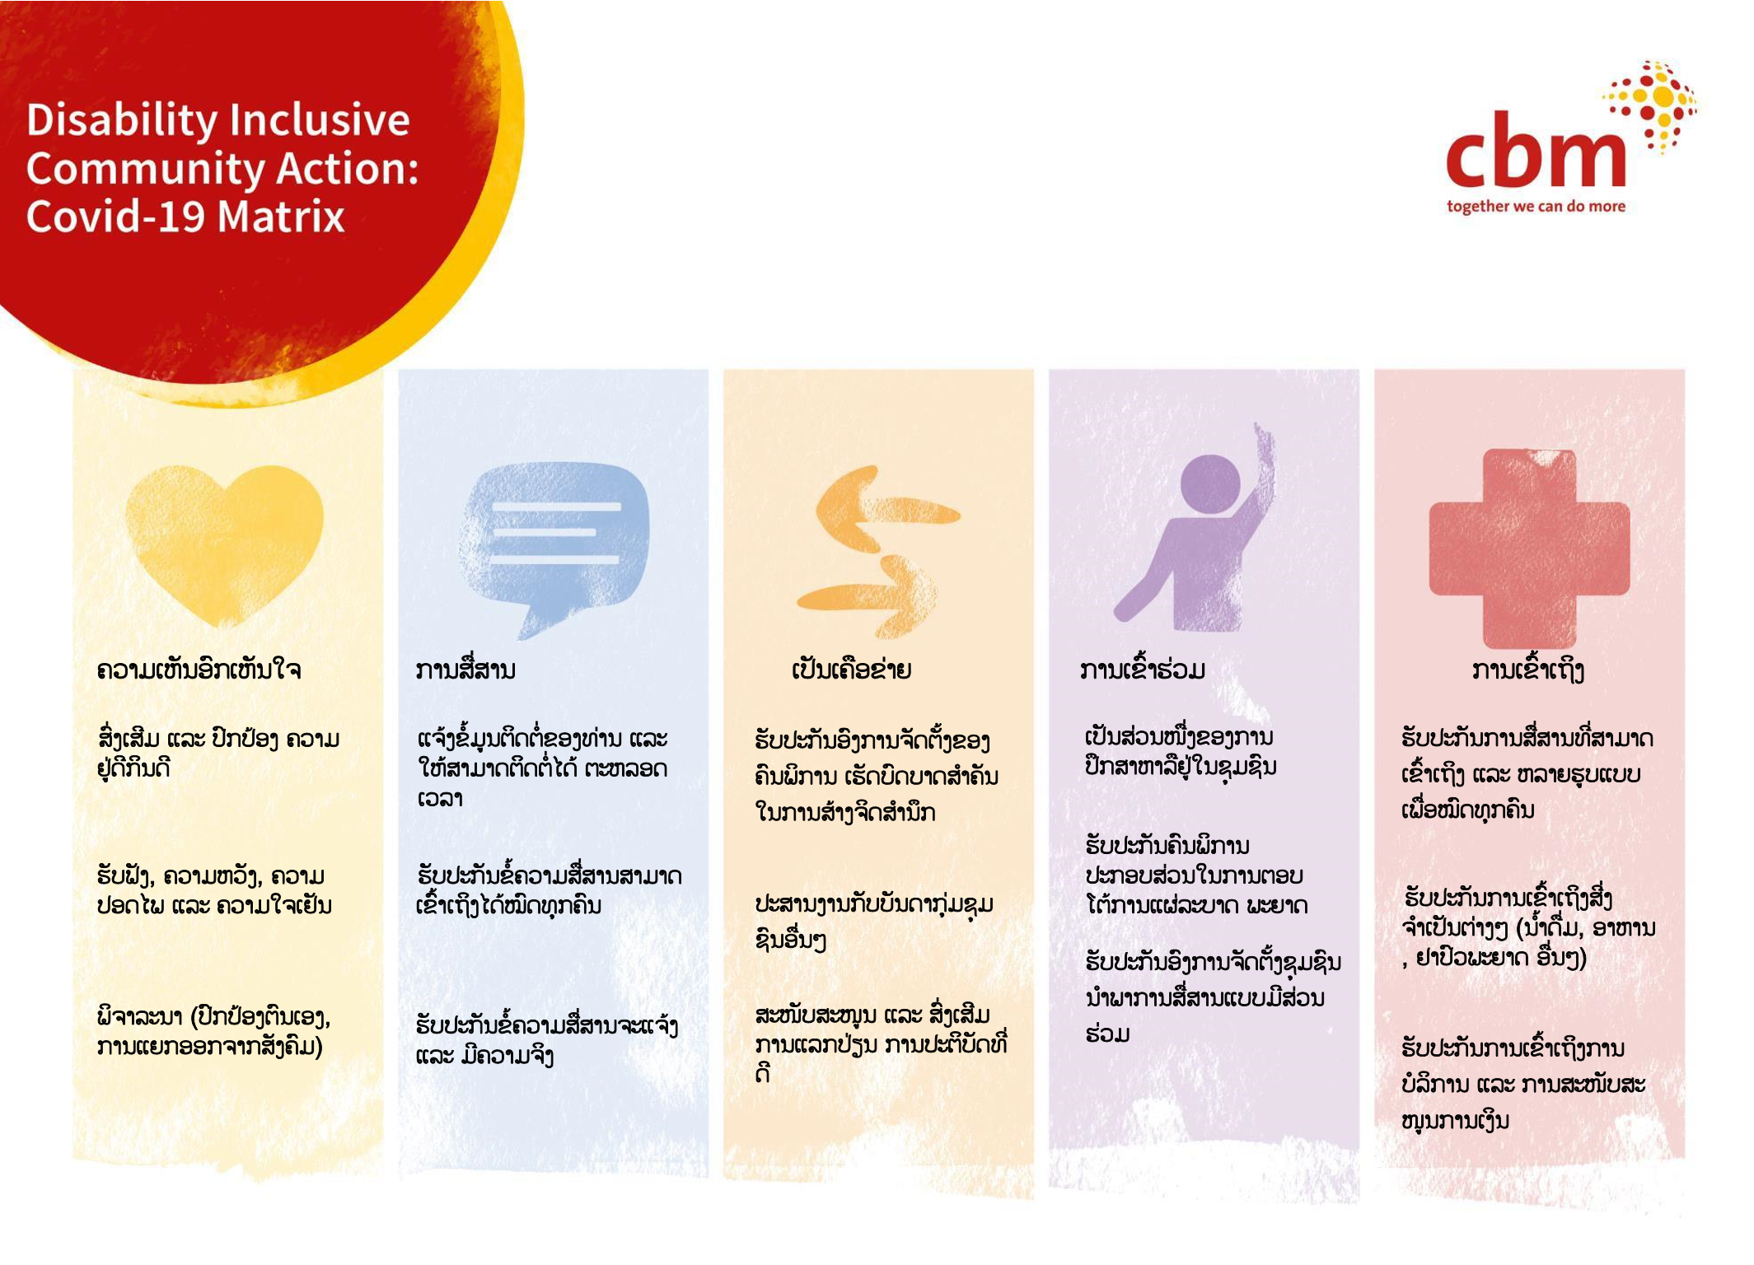The COVID-19 Matrix in Lao (Photo © CBM)

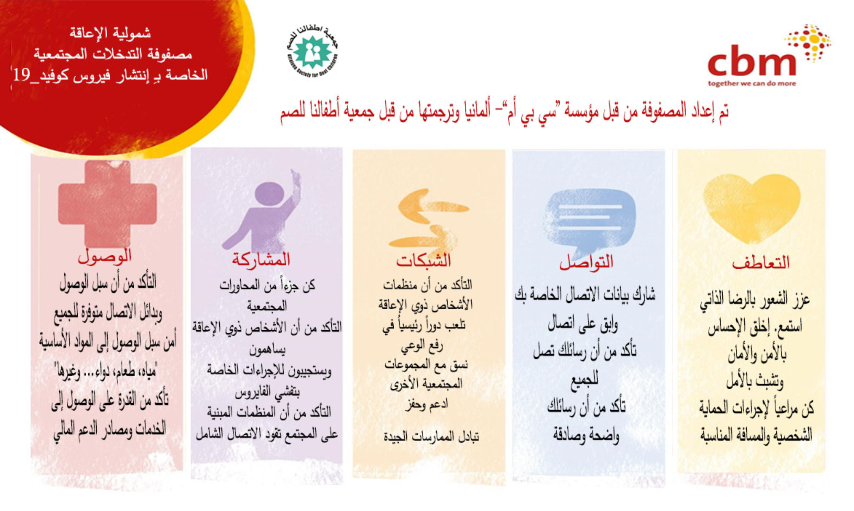
The COVID-19 Matrix in Arabic (Photo © CBM)

