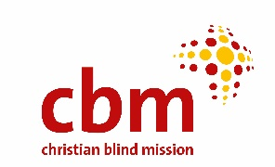

INVITATION TO TENDER

CBM Christoffel-Blindenmission Christian Blind Mission e.V is an international Christian disability and inclusive development organization whose primary purpose is to improve quality of life of the world’s poorest persons with disabilities and those at risk of disability, who live in the most disadvantaged societies.

CBM invites bids from eligible Tenderers for Supply and Delivery of New Motor Vehicles 2021

Reference No. | Description | Quantity
CBM/01/2021 | Double Cabin, manual transmission, 2500cc- 3000cc, Turbo Diesel engine. | 9
CBM/02/2021 | SUV4WD, 2800cc- 3000cc, Automatic transmission, Diesel. | 1

Prospective bidders should download the tender document from CBM’s website, containing detailed terms and conditions of tendering, ……………………………………………
Thereafter: - All bids enclosed in plain sealed envelope clearly marked: “Supply and Delivery of New Motor Vehicles; should be dropped at CBM Offices, on 11 Ring Road Parklands, Nairobi Kenya by 04th January 2022 close of business. A copy of the bid document in PDF format should also be sent to procurement.nairobi@cbm.org by 04th January 2022 close of business. Failure to meet the above requirements will lead to automatic disqualification. All bids should be addressed to:
Tender Committee
CBM Christoffel-Blindenmission Christian Blind Mission e.V
11 Ring Road, Parklands
P.O. Box 58004-00200,
NAIROBI, KENYA

The successful firm will be required to sign CBM’s Safeguarding as well as Anti-Corruption Policy.
CBM is a child safe organization

