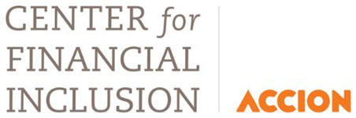

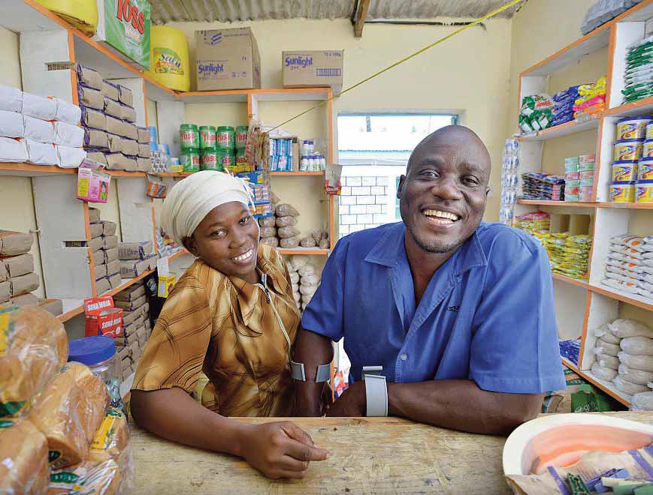

A case for Financial Inclusion of Persons with Disabilities

CBM Livelihood Technical Guideline

May 2016
© CBM Germany

Table of Contents
1. Rationale 2
2. Objective 3
3. The Legal and Business Case 3
4. Change Model 4
5. Economic Inclusion 4
A. Strengthen the institutional commitment and code of ethics 5
B. Review and amend key policies to prevent discrimination 5
C. Entry into partnerships with local disability organisations 5
D. Staff training 5
E. Hiring of persons with disabilities 6
F. Reasonable accommodation and universal design 6
G. Mainstreaming committee 6
H. Risk assessment tools 6
Conclusion 7

Rationale

Literally hundreds of millions of persons with disabilities are fully capable of working and contributing to the economic well-being of their families but find themselves unbanked and excluded from the global and national economies.
At a macroeconomic level, the World Bank estimates that between 5% and 7% of GDP is forgone by the economic exclusion of persons with disabilities. At the microeconomic level, financial service institutions are losing out on a large and attractive market segment. For example, persons with disabilities comprise as much as 15% of the population in developing countries; yet based on anecdotal evidence, only 0.5% of current microfinance clients come from this under-served community. Disability inclusion represents a wonderful opportunity to “do well by doing good”– an achievable win-win situation for nations and their citizens and for inclusive financial service providers.
Persons with disabilities in low- and middle-income countries are not only exposed to the same factors that cause poverty for others – they also face barriers that limit equitable access to health care, education, skills development, social participation and other services, further reducing their chances of securing decent work. These barriers include a lack of information about rights, benefits and opportunities for economic empowerment, inaccessible workplaces and public transport, as well as negative stereotypes and deeply ingrained prejudices about disabilities or their lack of abilities.
There are additional barriers in gaining access to microfinance institutions and financial services through banks and savings groups, such as a lack of physical access, and the absence of sign language interpreters and Braille signage. Negative attitudes and misunderstanding on the part of both financial institutions and persons with disabilities can, however, be greater obstacles. For example, it can be difficult for persons with disabilities to become members of savings or loan groups because group members do not consider them as credit-worthy.
It is imperative that we break down these attitudinal barriers, which often lead to poverty and marginalisation – even within the person’s own family. When given the opportunity to take part in economic empowerment initiatives, persons with disabilities are just as productive and efficient as non-disabled persons doing the same job. The social capital aspect through improved self-esteem and the respect of and acceptance by others is also an important factor to consider.

Objective

This technical guideline highlights barriers faced by persons with disabilities and makes recommendations to CBM Member Associations, Regional Offices and partners on how to engage with the financial sector to promote equitable financial inclusion of persons with disabilities.

The Legal and Business Case

The landmark UN Convention on the Rights of Persons with Disabilities specifically mandates economic inclusion programmes. Article 27 of the Convention underscores the important role that economic empowerment plays in integrating persons with disabilities into civil society. Indeed, ratifying countries are required to promote opportunities for formal employment, self-employment, entrepreneurship, the development of cooperatives, and starting one’s own business, as well as inclusive social protection.
In strategic economic-development terms, inclusive social protection involves enabling persons with disabilities to make the transition from being recipients of tax-funded social assistance to being contributors to social insurance systems.
While the legal and moral basis for inclusive livelihood development is solid, the business case is equally strong.
According to the World Report on Disability (2011), by the age of sixty, 40% of humanity has some form of acquired disability, and the demographic reality of an aging global population is incontrovertible. This creates an impetus for societies that are inclusive of person with disabilities. A financial institution that distinguishes itself by its high accessibility standards will have a competitive advantage in future over those that don’t. Doing the right thing is also good business, and this needs to be emphasised to all financial institutions.
The International Labour Organisation (2011) states that: People with disabilities make good, dependable employees and several Microfinance Institutions (MFIs) in India have come to the conclusion that they actually make better clients. Many cases document comparable productivity, lower accident rates and higher job retention rates between employees with disabilities and a company’s general workforce. Hiring people with disabilities can contribute to the overall diversity, creativity and morale in the workplace and enhance a company’s image among its staff, community and customers.
Numerous corporations including DuPont in the USA, Carrefour in Europe and Asia, and KFC restaurants operated by deaf persons in Cairo have discovered that employing persons with disabilities makes good business sense. An IT company in Bangalore, Vindhya Infomedia, in which Accion has an equity investment, has employed over 900 persons with disabilities, which represents 90% of their workforce. Designmate in Ahmedabad employs 340 persons with disabilities as 3D software developers. When recruiting staff, they offer priority to persons with disabilities as a successful business model, based on their observation that persons with disabilities are more dedicated and productive than employees without disabilities and have lower attrition rates when offered an accessible and conducive workplace.

Change Model

Despite enormous physical, communication, attitudinal, legal and process barriers, millions of persons with disabilities are successful in business and have achieved financial independence. But most of their success has been based on individual efforts, family, or support from development organisations, and these are the exception rather than the rule.
What these trailblazers teach us is that small accessibility changes and modest support can transform life outcomes. By lowering the barriers to financial inclusion (often in very low-cost ways) many more can become economically self-sufficient, having the opportunity to earn a living through work they choose on an equal basis with others, and serve as inspirational role models. In a series of small-scale initiatives across multiple continents, this is exactly what has occurred. It is time for the learnings from such efforts to be fully leveraged and brought to scale.

Economic Inclusion

Based on their extensive experience, CBM and the Center for Financial Inclusion at Accion (CFI) have developed inclusion guidelines, position papers and a reference guide to serve as disability-inclusive tools for implementation of livelihood and financial inclusion programmes.
These tools can be used to create awareness and offer guidelines for economic empowerment programmes, financial institutions and savings and loan groups to make inclusion of persons with disabilities a reality.
People with disabilities have the same needs for a broad range of financial services as other community members, including a secure and convenient place for savings; access to credit for income smoothing and investments; easy money transfer; access to automatic teller machines; risk, life and health insurance; and social protection such as pensions.
Financial institutions, employers and development organizations are encouraged to facilitate unhindered access to these services and:

Strengthen the institutional commitment and code of ethics
Concrete buy-in from senior leadership and all staffing levels to ensure a good level of understanding of the concept of inclusion and rights of persons with disabilities. Develop a code of ethics with specific guidance on how employers must treat clients and potential clients with disabilities, and provide staff training and monitoring mechanisms to ensure full compliance.

Review and amend key policies to prevent discrimination
Review policies, guidelines and practices, examine client recruitment methods, loan application and interview processes, staff incentives, and the way information is collected, stored and presented. Ensure that all references to direct or indirect discrimination against persons with disabilities are amended or removed. Check for discriminatory practices amongst employers/employees that are unintentional, or due to traditional belief and practice, faith-based, prejudice or lack of information.

Entry into partnerships with local disability organisations
Customisation is essential to success. Ensure compliance of tools, training courses and guidelines with local legislation, policies and needs by subjecting them to review by Disabled Peoples Organizations (DPO) and other stakeholders. DPOs representing civil society and government-appointed national disability councils exist in almost all countries and offer advice or training on inclusion of persons with disabilities in mainstream settings.

Staff training
Train staff to increase their awareness and acceptance of the national and international legal framework concerning the rights of persons with disabilities. This will emphasise the credit-worthiness of clients with disabilities, citing relevant examples. Offer sensitivity training at all organisational levels to increase the ability of staff to become proactive, and sensitise other key stakeholders on the importance of non-discrimination. Special attention will be paid to the training of loan and field officers, and others who will interact most with clients with disabilities.

Hiring of persons with disabilities
Actively recruit persons with disabilities at board and staff levels, and encourage persons with disabilities to apply for vacancies. Ensure that human resource policies take into account disability-specific needs such as physical accessibility and access to information and communication technology. Interaction with staff and clients with disabilities to ensure that inclusion becomes part of the permanent corporate culture.

Reasonable accommodation and universal design
Clients with disabilities should not be excluded from using financial services due to the barriers already highlighted in section 4.
The UN Convention on the Rights of Persons with Disabilities obliges employers to provide reasonable accommodation to their staff so that they can take up employment opportunities on an equal basis with others.
Such measures can include physical access ramps, accessible toilets, and the availability of information in Braille or through sign language interpreters. An accessibility audit can help to identify where change is needed.

Mainstreaming committee
Inclusive livelihood requires commitment at all levels in planning, implementation, monitoring and reporting, to ensure consensus-based approaches, and that the needed changes are made effectively and efficiently. The establishment of a mainstreaming committee consisting of persons with disabilities and trained staff from key departments is recommended. This group should be responsible for developing a mainstreaming action plan, monitoring implementation, and reporting to senior management.

Risk assessment tools
Financial institutions should develop disability-specific risk assessment tools and offer insurance covers to ensure that persons with disabilities are not left destitute in case of failing health or due to advanced age. Since this group is at a high risk for any financial institution, developing a risk assessment tool could identify corresponding mitigating measures. For example, incorporating special insurance for these populations at risk will promote inclusion.

Conclusion

Disability is both a cause and a consequence of poverty, contributing to increased vulnerability and social exclusion of persons with disabilities from mainstream socio-economic activities. For the majority of persons with disabilities in the world, self-employment through micro enterprise development represents the most viable form of economic activity. The main barrier to a greater uptake of informal sector work by persons with disabilities is lack of access to comprehensive financial services including credit. Therefore, existing financial institutions and services must be opened up to persons with disabilities to make inclusion a reality.
The United Nations 2015-2030 Sustainable Development Goals make explicit reference to persons with disabilities and carries the tagline, “Leave No One Behind.” It is indisputable that, to meet poverty-reduction targets, persons with disabilities must move from the periphery to the centre of the world’s poverty alleviation effort.
CBM and ACCION urge the global community of practitioners to dismantle the barriers that up to now have precluded the vast majority of persons with disabilities from access to finance, livelihood and economic participation, and facilitate equitable access to all mainstream financial services to achieve universal inclusion.

Acknowledgement:
Special thanks to Joshua Goldstein of The Center for Financial Inclusion at Accion (CFI) as co-author, Barney McGlade, Karen Heinicke-Motsch, Mike Davies, Nirad Bag, (all of CBM) for their significant input to this position paper.
CBM is an international Christian disability development organisation, committed to improving the quality of life of persons with disabilities in the poorest countries of the world. With over 100 years of professional experience, CBM works alongside 600 local, national and international partner agencies in the fields of healthcare, education, rehabilitation and livelihood development, reaching about 40 million people annually in 64 countries (2014). In 2014, CBM’s technical and financial support enabled about 130,000 persons with disabilities to obtain relevant skills and employment.

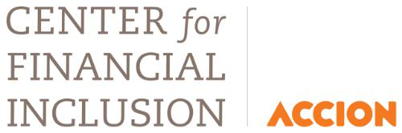
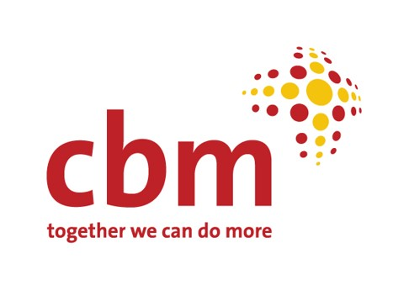
The Center for Financial Inclusion at Accion (CFI) is an action-oriented think tank working toward full global financial inclusion. Constructing a financial inclusion sector that reaches everyone with quality services will require the combined efforts of many actors. CFI contributes to full inclusion by collaborating with sector participants to tackle challenges beyond the scope of any one actor, using tools that include research, convening, capacity building, and communications.

CBM Livelihood Community of Practise
Contact: Hubert Seifert –Senior Livelihood Advisor CBM
P.O.Box 83988, 80100 Mombasa - Kenya
Email:hubert.seifert@cbm.org
Mobile Phone: +254(0)724053470
www.cbm.org

Center for Financial Inclusion at Accion:
Author and program contact: Joshua Goldstein
Vice President for Economic Citizenship and Disability Inclusion
10 Fawcett Street, Suite 204, Cambridge, MA 02138 - USA
Email: jgoldstein498@gmail.com Skype: josh.goldstein1953
Phone: 617-953-9865
www.centerforfinancialinclusion.org

WHO World Report on Disability (2011) http://www.handicap-international.org/uploads/media/goodpractices-GB-2coul.PDF
UNCRPD has been ratified by 159 countries, as of October 2015
https://centerforfinancialinclusionblog.files.wordpress.com/2014/11/josh_goldstein_keynote_uganda_11-14.pdf
Annapurna, ESAF and Equitas, three MFI partners of the CFI in India, believe this strongly. They plan to obtain good data in the coming year to substantiate this conclusion.
The Center for Financial Inclusion at Accion (CFI) is a USA based action-oriented think tank working toward full global financial inclusion
(http://www.cbm.org/article/downloads/78851/CBM_Inclusion_Made_Easy_-_Part_A.pdf), http://www.cbm.org/article/downloads/78851/CBM_Disability_Inclusion_-_Livelihood.pdf http://www.cbm.org/article/downloads/54741/did_series1_The_Future_is_Inclusive.pdf
http://www.centerforfinancialinclusion.org/programs-a-projects/pwd
http://www.centerforfinancialinclusion.org/programs-a-projects/pwd/framework-for-persons-with-disabilities, where the complete tools and training, as well as recommendations A-H, can be found.

