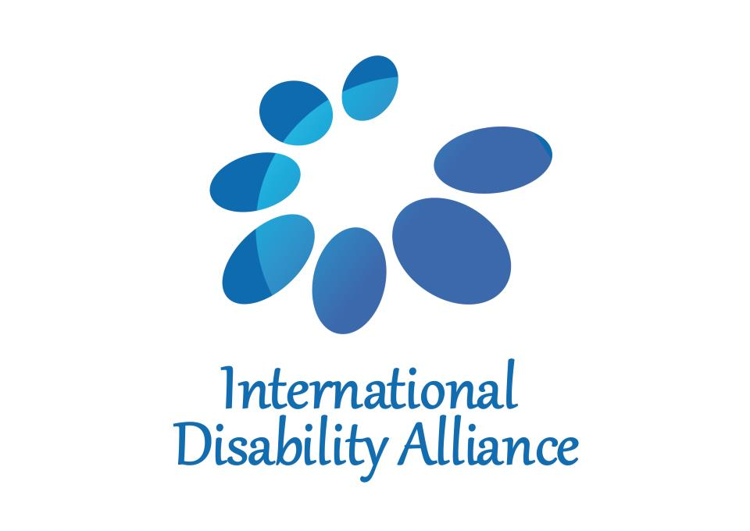
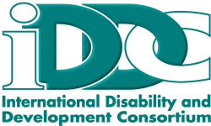

Recommendations for the post-2015 political declaration to be inclusive of persons with disabilities

The post-2015 political declaration must include persons with disabilities to create a fully inclusive society for all and truly to ensure that no one is left behind. Approximately one billion people – 15 per cent of the world’s population – are persons with disabilities and must be recognised by all Member States and be included in the new development framework.

The International Disability Alliance (IDA) and International Disability and Development Consortium (IDDC) recommend that the political declaration:

- Include an explicit reference to the United Nations Convention on the Rights of Persons with Disabilities (UN CRPD).
Rationale: The UN CRPD, adopted by all Member States of the UN General Assembly, is a legal obligation for the 152 countries that have ratified it, and represents a development treaty for all States to ensure that no one is left behind.

- Pledge that the post-2015 development framework will leave no one behind by explicitly referencing persons with disabilities.
Rationale: Persons with disabilities were absent from the Millennium Declaration and remained so in policies and processes related to the Millennium Development Goals. As a result, the one billion-strong population of persons with disabilities has remained excluded from a framework that sought to eradicate the precise conditions this population continues to face. This cannot happen again.

- Guarantee that upon agreement of a new set of sustainable development goals that no target will be considered met unless met for all, including persons with disabilities.
Rationale: Sustainable and inclusive economic development growth, social development, and environmental protection are the overarching objectives and fundamental values of the post-2015 development framework and it is imperative that these three pillars of sustainable development are achieved through specific actions, which are inclusive of persons with disabilities.

For further information please contact Ms. Orsolya Bartha obartha@ida-secretariat.org or
Dr. Elizabeth Lockwood elizabeth.lockwood@cbm.org

