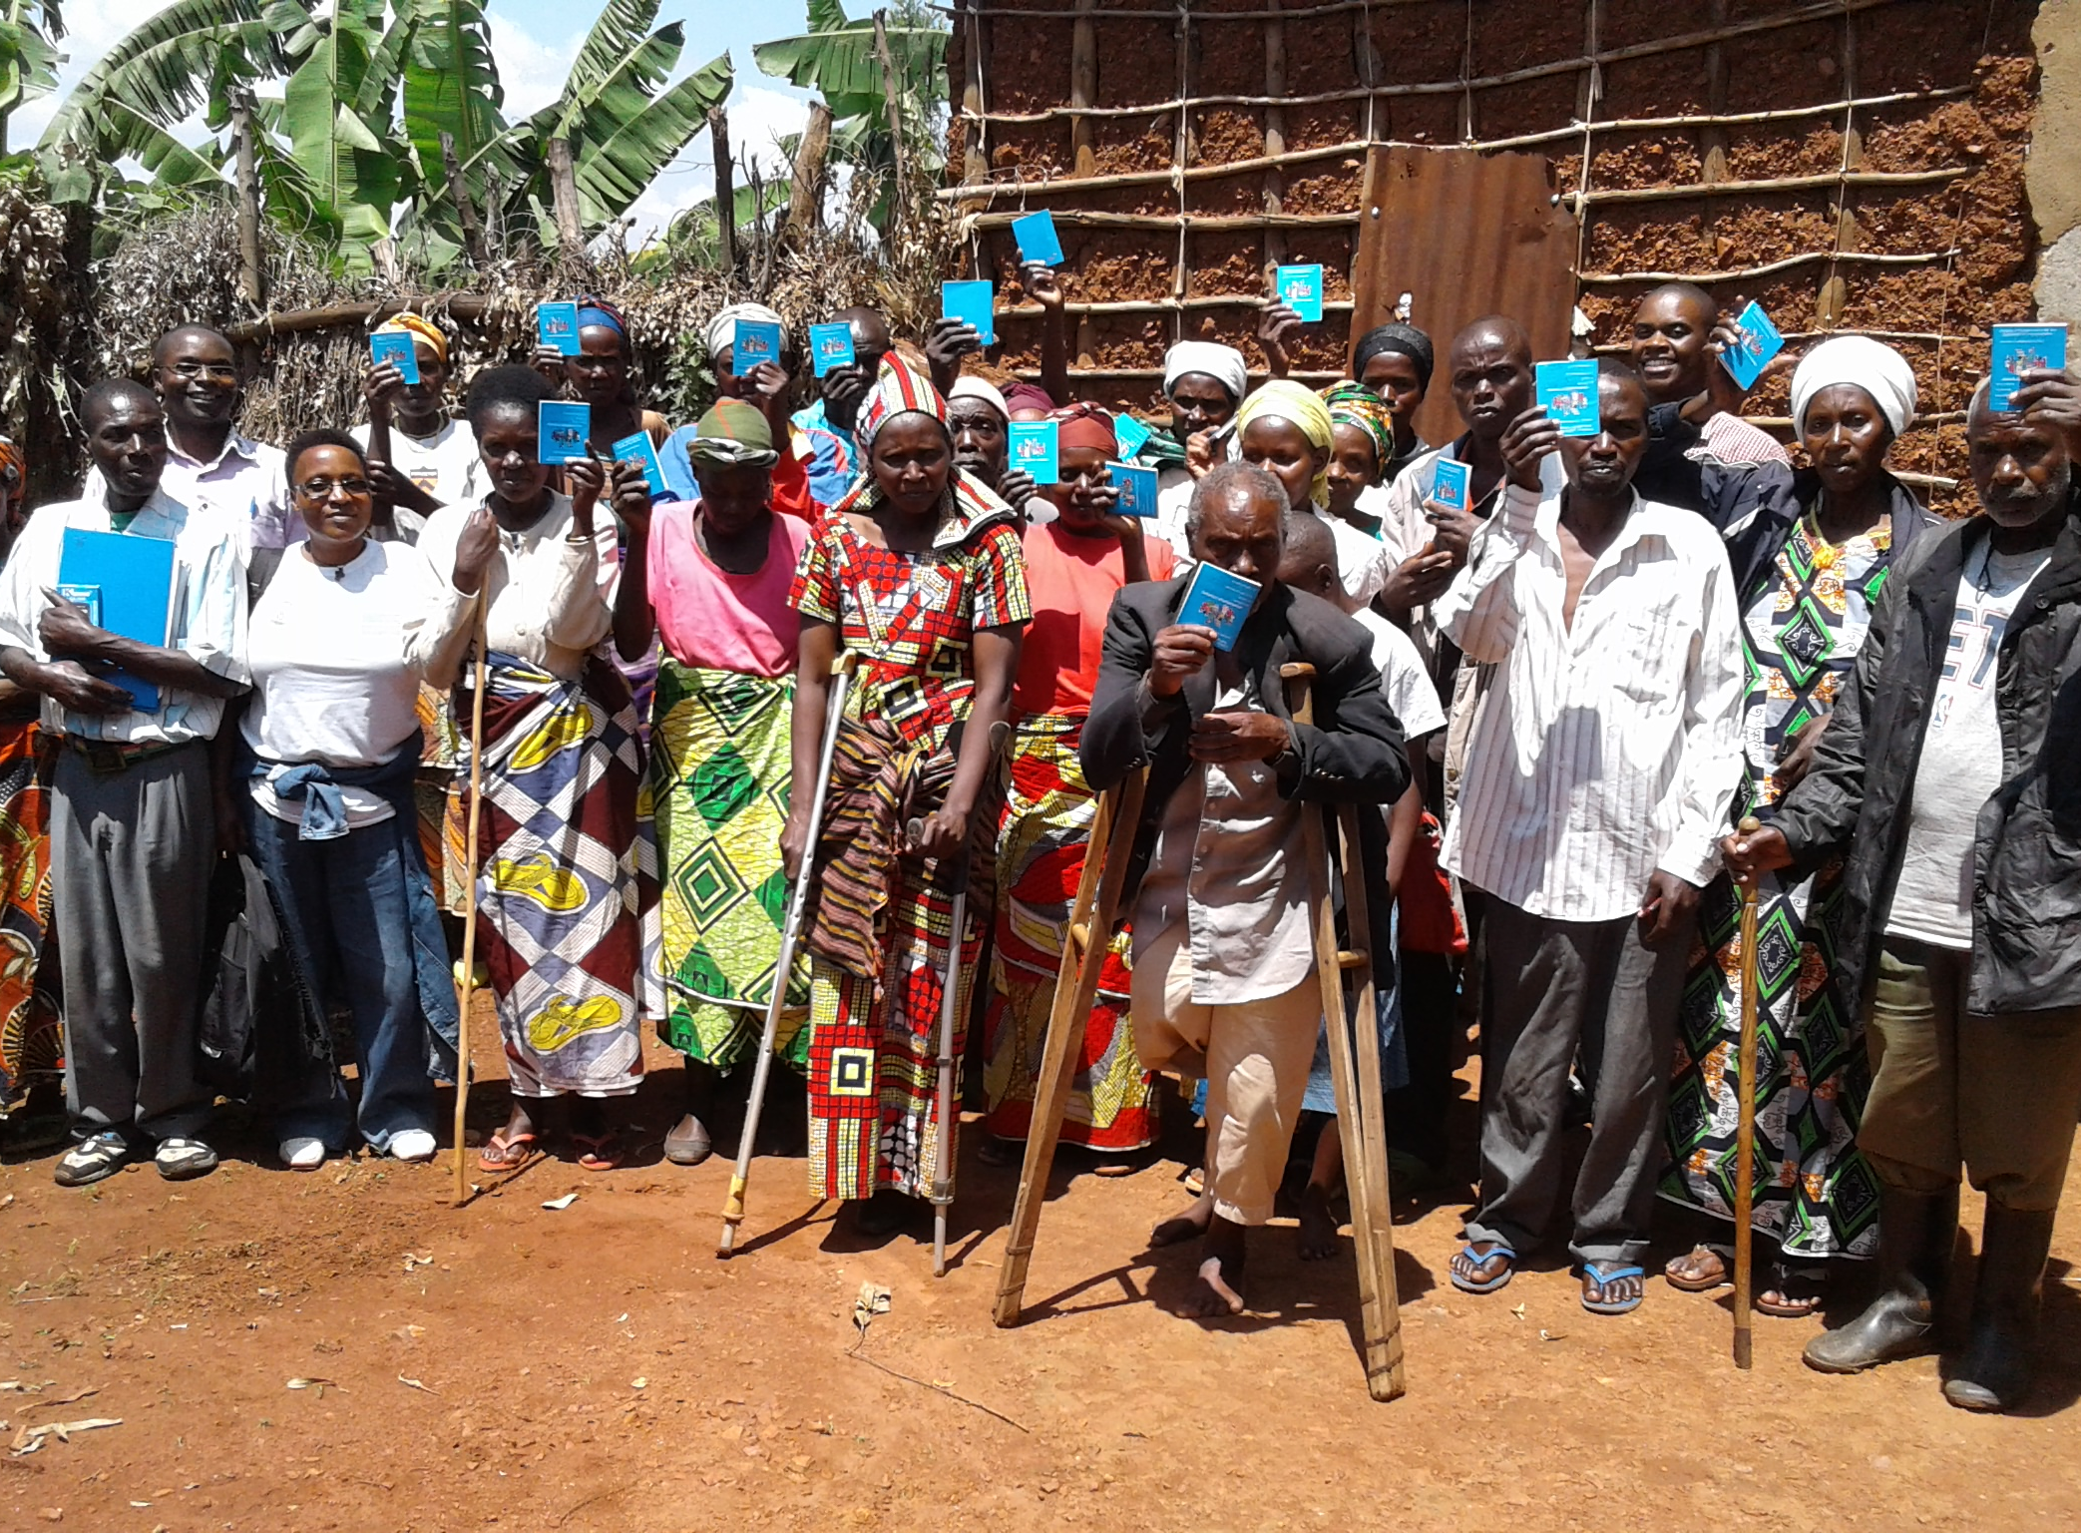
© CBM

SAVINGS GROUP CONCEPT

CBM LIVELIHOOD COMMUNITY OF PRACTISE

POSITION PAPER

Revised May 2016
Contents

1. INTRODUCTION 2
2. BACKGROUND ON SAVINGS GROUPS 3
A. VSLA METHODOLOGY 3
B. COMPLEMENT TO MFIS 4
C. STRENGTHS 5
D. CONSTRAINTS 6
E. OPPORTUNITIES FOR INNOVATION 6
3. FINANCIAL EXCLUSION OF PERSONS WITH DISABILITY 7
4. UGANDA – A SAVINGS GROUP PROGRAM FOR PEOPLE WITH DISABILITIES 8
5. CBMs LIVELIHOOD STRATEGY 10
6. PROMOTION OF THE SAVINGS GROUP MODEL BY CBM 11
7. WEBSITES 12

INTRODUCTION
Governments, donors, and international financial institutions across the globe have increasingly recognised that access to financial services can play a pivotal role in poverty alleviation and in decreasing the vulnerability of poor people. Financial inclusion has moved up the agenda of emerging and developing countries, committing themselves to promote legislation and program development to achieve financial inclusion of the poor members of society.

Yet 2.7 billion people remain financially excluded. In most developing countries, more than two-thirds of the adult population has no access to formal financial services, and in sub-Saharan Africa, financial exclusion is as high as 76 per cent. Exclusion is typically highest amongst women, youth and the very poorest segments of society which includes persons with disability.

The low and unpredictable income of poor people makes it difficult for them to bank with formal financial institutions. Likewise, national and international banks have struggled to find a business case for reaching the world’s poorest people given the expectations of their shareholders and the desire for sufficient profit margins. As a result, poor people have largely discounted formal financial institutions and vice versa.

The microcredit boom of the 1990s sought to engage poor people in the semi-formal financial sector, but some irresponsible credit lending by profit-oriented institutions has seen the sector called into question. There has also been increased recognition that poor people need a range of financial services not just credit, given that their incomes are ‘low, unpredictable and irregular’.

However, financial exclusion has led to the development of resourceful indigenous community-based solutions including savings groups. By saving small amounts, groups gradually begin to save, and subsequently access loans from their own capital. Indeed there is something of a savings-led revolution now taking place across the world, with seven million (2013) savings group members.

Savings rather than debt can smooth irregular income patterns and meet basic household consumption needs. Once a savings culture is established, some people go on to establish small businesses. As group savings accumulate over time, the security of the money can become a challenge and the need for the safety of a formal financial institution becomes stronger. Savings therefore offer a stable springboard from which to begin the path to formal financial inclusion.

BACKGROUND ON SAVINGS GROUPS
Community-managed savings-led approaches to financial services for the poor have a long and successful history, particularly in India where there are over two million self-help groups (SHGs), serving 30 million members. More recently, community-managed approaches have proliferated in remote, rural regions in Africa and Asia. One such approach, Village Savings and Loan Associations (VSLAs), has been pioneered by CARE and has been successfully adapted by other agencies.

VSLAs are self-managed groups that do not receive any external capital and provide people with a safe place to save their money, access small loans, and obtain emergency insurance. The approach is characterized by a focus on savings, asset building, and the provision of credit proportionate to the needs and repayment capacities of the borrowers.

Groups are low-cost, simple to manage and can be seen as a first step for people to reach a more formal and wider array of financial services. VSLAs can dramatically raise the self-respect of individual members and help to build up social capital within communities, particularly among women who represent approximately 70 percent of members.

VSLA METHODOLOGY
Key elements of the VSLA approach include the following:

Self-selection: An external agency such as International NGOs or a local development organization introduces the concept of savings and loan services to the community and then facilitates the formation of VSLAs comprised by 15 to 30 persons. Because trust is fundamental to the effective functioning of a VSLA, members select each other to form their group.

Training: Training is provided over a few months to help members define the VSLA’s purpose, elect members to serve as officials, and set terms for savings and loans, including interest rates, repayment schedules and penalties for late payments or missed meetings. The group is also trained in a system to collect savings and make loans, record transactions, and run weekly meetings. The methodology offers recordkeeping techniques suitable for literate or illiterate people.

Governance: Each VSLA elects a chairperson, secretary, treasurer, and two money-counters who form its executive committee. In addition, members select three others and entrust each with a key to one of the three locks on the cashbox where the group’s funds are kept. This governance structure serves as an internal control system. All transactions – the collection of member savings and the disbursement of loans – are carried out at weekly meetings in front of all members, ensuring transparency and accountability.

Financial Services: VSLAs begin by collecting weekly savings from members. Savings are accumulated in the form of shares at a price agreed upon by the group. The use of shares simplifies recordkeeping. Once sufficient savings have accumulated in the cashbox over four to five weeks, loans are offered to members. Typical loans range from $10 to $20. The group may set an interest rate for loans from around 5 to 10 percent monthly. At the end of the year, members receive a return on their savings ranging from 30 to 60 percent annually generated from interest and fees collected throughout the year. In addition, VSLAs set up an insurance fund, often called a social fund, to enable members to access money in emergencies or at particularly vulnerable times. The group determines if the emergency funds are distributed as grants or as interest-free loans with flexible repayment.

Audit: Some nine to twelve months after the VSLA is formed, the group conducts an “action audit” whereby it pays out savings and earnings from interest and fees, closes its books, and disbands. The action audit is usually timed to provide a lump sum to members at critical times in the year when access to money is needed, for example to pay for school fees or inputs at the start of the agricultural season. It also enables members to leave the group and new members to join. Most groups reconstitute themselves and resume the savings and loan process.

Agency facilitation: From the start of the VSLA’s operations to the time of the first action audit, the agency observes its meetings and supports the executive committee as needed to ensure that procedures and systems are working well. If there are no issues, the group functions independently thereafter.

COMPLEMENT TO MFIS
VSLAs are complementary to MFIs. They serve people living in remote places whose income is low and irregular, need to save cash in small amounts, and have limited demand for credit because markets for their products are weak. Such populations are costly for MFIs to serve. Through VSLAs, some community members may build up their assets enough to be attractive clients for MFIs, credit unions and banks. There is growing recognition of the importance of VSLAs as an entry-level component of a vibrant financial system.

STRENGTHS
  - Rural and poverty outreach: Groups can operate in remote or sparsely populated areas where more formal financial services are not cost-effective or available.

  - Low operating costs: VSLAs avoid most of the infrastructure, transport, communications and personnel costs incurred by a MFI. Cost per member for the startup of VSLAs ranges in Africa from $20 to $60; in Asia, from $10 to $20.

  - Capital remains within group: Interest paid on loans remains within the group, and builds the cash assets of the members.

  - Transparent, democratic and flexible: Members determine their own rules and decisions are made through consensus with minimal paperwork. Members save on a flexible schedule agreed upon by the group and can vary the amount saved each period. Because members usually know each other well, there is more flexibility in offering quick loan disbursement and individualized repayment schedules.

  - Client debt level: Loans are matched to each member’s capacity to repay, based on the group’s decision.

  - Conduit for other interventions: Some agencies use groups to provide other services such as health education.

  - Opportunity for increased economic activity: VSLAs can be seen as a first step in financial access. While some groups will never link to the formal financial system, others will leverage their learning about financial services in the group context to seek access to more formal and a wider array of financial services.

CONSTRAINTS
  - Limited capital: Since VSLAs depend on members’ limited savings capacity to provide the group’s lending capital, loan demand by members can outpace supply.

  - Limited product offering: Without a linkage to a formal financial institution, products within the group are limited to simple forms of savings, loans and insurance that may not match well the needs of all members.

  - Interrupted savings: The yearly distribution of savings and caps on shares interrupt members’ efforts over time to accumulate large amounts of capital (although at the first meeting when the group reconstitutes, savings can be reinvested at five times the normal weekly amount).

  - Elite capture: More powerful group members can exploit the loan fund by taking more than their share of loans and by defaulting. A way to mitigate this has been to place a cap on the number of shares (savings) which can be purchased by any one member and by restricting loan amounts to multiples of shares held.

  - Exclusion: Since groups are self-selecting, there is a risk that members of the community will exclude poorer individuals from groups.

  - Theft: Cashboxes are maintained by the groups and may pose a risk of theft. In practice, with the exception of the first few weeks when groups start to save and the last months when loans are being repaid, the cashbox is nearly empty as funds are circulating among the members. To minimize risk, groups can be linked to banks which allow the groups to maintain savings accounts, particularly during the last few months prior to the action audit.

OPPORTUNITIES FOR INNOVATION
Several opportunities for innovation have been identified which, if addressed, would spur scale up of financial services to the poor.

  - Linkages to formal financial institutions: Over time, some members may need more diverse financial services and/or larger loan sizes which cannot be met by VSLAs due to the limitations outlined above. Agencies have piloted linkages with formal financial institutions such as banks, MFIs and credit unions in response to the demand for a broader range of services, however they must further address concerns of increasing costs to VSLAs (service fees, travel costs, etc.), creating over indebtedness, or otherwise destabilizing the group.

  - Income Generation: While VSLAs have been tremendously successful in poverty reduction and income smoothing, there are opportunities to enhance the opportunity for income generation and asset building.

  - Sustainability and quality: A challenge to rapid scale up is the sustainability and quality of services of VSLAs once they become independent. Some agencies are testing models whereby field agents based in the region provide scheduled monitoring for a fee paid by the group. Another experiment promotes VSLAs to form credit unions and other larger registered bodies that can provide support, such as negotiating fees with banks and assuring quality standards.

d. Building institutional linkages: Agencies can help VSLAs leverage their social capital and organizational capacity to link into agricultural development efforts, health and education.

FINANCIAL EXCLUSION OF PERSONS WITH DISABILITY
According to the World Report on Disability (2011) approximately 15 per cent of the global population have disabilities; 80 per cent of these individuals live in developing countries, and for those who live on less than $1 a day, one in five has a disability. The cost of disability is high for the affected individual, for his/her family and for society. In developing countries, 80–90 per cent of persons with disabilities do not have formal jobs, and government and charity support are in practice limited, so most of these people turn to self-employment.

The World Report on Disability states:

“Many people with disabilities have few assets to secure loans, and may have lived in poverty for years. Microfinance programmes are in principle open to all, including disabled people. But anecdotal evidence suggests that few people with disabilities benefit from such schemes. Some micro-finance programmes have been set up by disability NGOs and others target people with disabilities, but more evidence is needed on their effectiveness.
A review of the literature found obstacles in mainstream microfinance, so provisional schemes run by NGOs and disabled people’s organizations can help, because they give rise to social inclusion, participation, and empowerment. But both approaches are needed to achieve wider coverage and sustainability, given that microfinance has great social and economic impact for persons with disabilities.”

Mersland et al. (2009) explain that there are several mechanisms excluding disabled people from access to microfinance. These are exclusion by staff due to attitudes, exclusion by credit design, exclusion by non-disabled members in credit or savings groups, exclusion by the disabled persons themselves because of low self-esteem and repeated experiences of rejection during life and exclusion because of the disability itself. Findings in Mersland et al. (2009), Handicap- International (2006) and Thomas (2000) confirm that few disabled people access credit in traditional MFIs or donor-supported self-help schemes.

It is evident that people with disabilities have not had equal access to financial services incl. micro credit to facilitate livelihood development. Subsequently they have been largely excluded from productive participation in the economy particularly in developing countries and often live in abject poverty due to lack of social safety networks. There is a dire need to develop solutions that ensure the right to equal access of people with disabilities to opportunities for socio-economic empowerment to achieve full inclusion in society.

UGANDA – A SAVINGS GROUP PROGRAM FOR PEOPLE WITH DISABILITIES
The “National Union of Disabled Persons of Uganda” (NUDIPU) is an umbrella Disabled People Organisation (DPO), formed in 1987. NUDIPU is primarily a lobby group advocating for the rights and equal opportunities of persons with disabilities through legislation and policy development in Uganda.
Through funding from the Norwegian Association of the Disabled (NAD), NUDIPU commenced a livelihood program in 2005 with the aim of lobbying Microfinance Institutions in Uganda to promote inclusion of persons with disabilities. The objective of the project was to increase the awareness level of mainstream microfinance service providers of persons with disabilities as potential clients, removal of barriers and inclusion in their programs as equal clients. NUDIPU also created awareness among persons with disabilities and their organizations on the services provided by microfinance institutions.
This program has increased the level of awareness and has resulted in removal of barriers and inclusion of more persons with disabilities in MFIs. However it was realized that MFIs mostly reached persons with disabilities in or near urban areas who already had established businesses. NUDIPU arrived at the conclusion that standard credit-led MFI approaches are unable to meet the needs for financial services of people with disabilities in rural areas because their need is not for debt-led financial services, but primarily for savings-led services. Due to high operational costs and location in urban areas, MFIs are either not accessible to the target group or services can not be offered conveniently and competitively.
To fill the void, NUDIPU commenced a pilot program in seven eastern districts of Uganda in 2010 based on the VSLA model.
By December 2014 the programme covered 13 districts, consisted of 922 groups with 27,011 members incl. 17,741 Women (66%), and 3,907 Youths (16-25 years) (14.5%). The number of Persons with disabilities had reached 16,043 (Physical - 8,408, visual – 2,388, hearing – 1,567 and others – 3,681). The number of Members who started Income Generating Activities had reached 10,941
The accumulated Savings stood at EURO 988,000 while outstanding loans amounted to EURO 906,000. The programme cost per member was $ 34.
Groups apply the same principles as per the VSLA guidelines but must have a 60% majority of persons with disabilities. They allow also caregivers and no more than 15% well-wishers. These mixed groups help integrate people without disabilities into the programs to allow sharing of experiences while ensuring that persons with disabilities retain management control of the groups.
Groups are formed through self-selection usually covering a geographical area. Members receive intensive training for a period of 4 to 6 week by the Field Promoters who are paid by NUDIPU. The Field Promoters ensure that the by-laws are adhered to, they monitor progress and assist with conflict resolution. Groups usually become self-managed after 6-9 months. On completion of the first cycle, groups usually operate independently.
The groups formulate by-laws to govern their operations, conduct and determine the interest charged for loans and fees. They are required to contribute towards the cost of the start-up kit, which includes a cash box with three locks, money bags and member pass books and an accounts ledger.
Members buy shares weekly and can access loans after 6 weeks at an interest rate of 1% per week. At the end of an agreed cycle the accumulated savings and interest earnings are shared out amongst the members in proportion to the shares held. Members can use savings to buy shares when they commence the new cycle.
Each group may also have a social fund, which provides members a basic form of insurance to provide emergency assistance or cover medical and funeral expenses.
The NUDIPU district office captures financial data, gender distribution and client default rates. The data is centrally processed and submitted for inclusion in the VSLAs global statistics.
IMPACT
The NUDIPU Savings group program has been rated as very successful due to its high level of ownership by disabled people and socio-economic benefits to the target group. The primary benefits have been income smoothing through improved household income, food security and increased resilience to business related and personal setbacks.
The relatively low costs for training and start up, transparency and simple management principles have ensured a vast roll out.
The fact that there are minimal overhead costs involved and members share out incomes generated through interest and fees, makes the scheme very attractive and creates an incentive to mobilise savings.
There are minimal risks involved due to the group pressure, and subsequently write offs and default rates are very low. There is no need to attract external revolving or guarantee funds which allows quick replication and expansion.
The program has ensured a greater level of inclusion of persons with disabilities in society since they have become more active as entrepreneurs who have earned the respect of community members and are no longer being viewed as dependants on charity.
The level of self confidence of group members has reportedly increased which has had positive effects since some members have been elected into civic society and political positions.

CBMs LIVELIHOOD STRATEGY
CBM has been supporting partners working in the field of economic empowerment for many years through vocational training and skills development, formal or informal employment, micro finance and social protection schemes. In 2014, a total of 174 CBM supported training and employment programs reported that 130,554 persons benefitted from various interventions.
Traditionally most CBM-supported livelihood programmes have been small scale, with a tendency towards disability-specific skills development and employment, resulting in exclusion. With the paradigm shift towards mainstreaming there will be an emphasis on inclusive capacity building and livelihood creation.
The Livelihood Advisory working group recommends that CBM should gradually divert direct support from disability-specific livelihood programmes towards support for regional and national partnerships of DPOs, NGOs, the private and public sector, aimed at professionally managed and inclusive training and employment programmes. It was realized that in the long run this will reduce partner dependency on external donors, raise the number of clients and increase sustainability.
The inclusive livelihood strategic framework puts emphasis on ensuring that livelihood development is mainstreamed through global, regional and national partnership development.

PROMOTION OF THE SAVINGS GROUP MODEL BY CBM
During its planning workshops in 2013 and 2015, the CBM Livelihood Advisory working group discussed the VSLA/Savings group model and considered it as a suitable and viable strategy to achieve greater financial inclusion of persons with disabilities. Particularly in rural areas and informal settlements where most of the CBM target groups reside, this model was considered as a first stepping stone towards breaking the viscous cycle of disability and poverty.
A first CBM funded VSLA pilot programme commenced in Rwanda in November 2015 in partnership with the National Union of Disability Organisations of Rwanda (NUDOR). Within three months, 32 groups were formed with 982 members that had commenced savings and lending in a suburban and rural setting. CARE provide technical expertise and assisted in programme design and training.
The impressive outcomes so far achieved by the NUDIPU program in Uganda and NUDRO in Rwanda are evidence that this model can reach a significantly larger target group within a relatively short time span requiring lower investments compared to most of the special programs run by CBM partners currently.
Several donors incl. Bill and Melinda Gates Foundation, MasterCard Foundation, Barclays Bank UK, USAID, DFID and others fund the savings group concept on a large scale and international development partners incl. CARE, Plan, Oxfam, Catholic Relief Services, World Vision, Freedom from Hunger and the Aga Khan Foundation implement the programs. By end of 2015, there were 12 million members included in VSLA groups around the globe with a strong focus on Africa.
This creates a tremendous opportunity for CBM and its partners to tap into mainstream programs by lobbying the donor and INGO community to include persons with disabilities in their programs as a target group.
The Advisory Group recommends lobbying for inclusion of persons with disabilities into mainstream groups as a first priority as this would ensure inclusion and equal opportunities, requiring minimal investment. However persons with disabilities might find it challenging to be accepted as group members as a result of prejudices and self-selection criteria which can result in exclusion of a target group that is often perceived to be non-productive or dependant on charity. Affirmative action and sensitisation can assist in overcoming such attitudinal barriers.
However there is merit in promoting the development of special savings groups consisting primarily of person with disabilities and care givers similar to the NUDIPU and NUDOR approach, particularly in areas where mainstream saving groups do not exist. This also applies to CBM Partners who run Community Based Rehabilitation (CBR) programs since they can become entry points to facilitate the establishment of savings groups.

WEBSITES

- CBM: Promotion of Savings and Loan groups in Community Based Rehabilitation Programmes -CBM Livelihood Technical Guideline-
http://www.cbm.org/article/downloads/54741/CBM_Technical_Guideline_SavingsgroupsMarch2016__final_.pdf
- http://savingsgroups.com
- http://vsla.net
- http://www.oxfamamerica.org/issues/community-finance/sg-2013-conference/savings-conference-2013/sg-2013-presentations
- http://savings-revolution.org/learn-more/
- http://savings-revolution.org/videos/
- http://savings-revolution.org/guides-and-manuals/savings-group-formation-management/oxfam-freedom-from-hunger/

WORLD VISION INT.:

- http://worldvisionmedia.ca/asca/how-it-works
- http://www.wvi.org/sites/default/files/SG%20PM%20Revised%20Aug2015%20v8%20(Sect5%20pending).pdf
- http://www.wvi.org/disability-inclusion/publication/including-persons-disabilities-savings-groups
- http://www.wvi.org/disability-inclusion/video/including-people-disabilities-savings-groups

Introduction to savings groups:

- http://www.seepnetwork.org/filebin/pdf/resources/Savings_FINAL_web.pdf
- http://www.youtube.com/watch?v=PTYbW_vgV9U&feature=youtu.be

A saving for change program in action in Malawi:

- http://www.youtube.com/watch?v=mb_ArkF4McM
- http://www.youtube.com/watch?v=W1-Ked7g-Wo

Savings Group training guidelines –International Rescue Committee-:

- http://www.fsnnetwork.org/sites/default/files/EA$E%20Facilitators%20Guide-VSLA.pdf

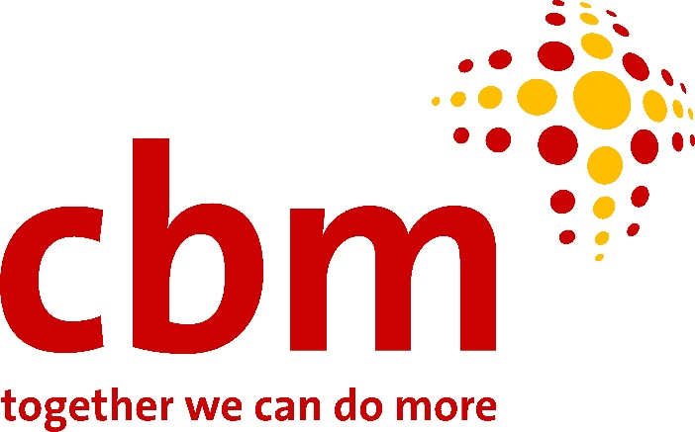

CBM
Stubenwald-Allee 5
64625 Bensheim
Germany
www.cbm.org

Hubert Seifert
CBM Senior Adviser for Livelihood
P.O. Box 83988 – 80100 Mombasa, Kenya
Email:hubert.seifert@cbm.org
Mobile Phone: +254(0)724053470

CBM is an international Christian development organisation, committed to improving the quality of life of people with disabilities in the poorest communities of the world.
More information

This number has increased to 12 million by end of 2015
Banking on change: Braking the barrier to financial inclusion https://www.home.barclays/content/dam/barclayspublic/docs/Citizenship/banking-on-change.pdf
http://www.mastercardfdn.org/pdfs/VSLA_Website_Brief.pdf
http://www.who.int/disabilities/world_report/2011/report.pdf

